Assessment: Mock Lab Exam 01

Student Name: Leanne Seaward

Lab Professor Name: Leanne Seaward

Lab Section Number: *3xx*

Due Date: Oct 6th, 2021

# UML Diagram

|  |
| --- |
| Money |
| -numLoonie: int  -numToonie: int  -numQuarter: int  -numDime: int  -numNickel: int |
| +Money()  +getNumLoonie(): int  +getNumToonie(): int  +getNumQuarter(): int  +getNumDime(): int  +getNumNickel(): int  +setNumLoonie(numLoonie: int): void  +setNumToonie(numToonie: int): void  +setNumQuarter(numQuarter: int): void  +setNumDime(numDime: int): void  +setNumNickel(numNickel: int): void  +computeTotalMoney(): double |

# Screenshot of Running Program

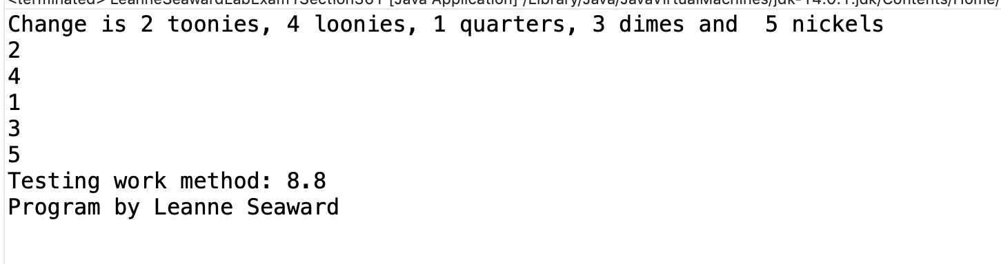

# References / Sources Cited (optional section as needed)